**System Architecture**

**UML Class Diagram**

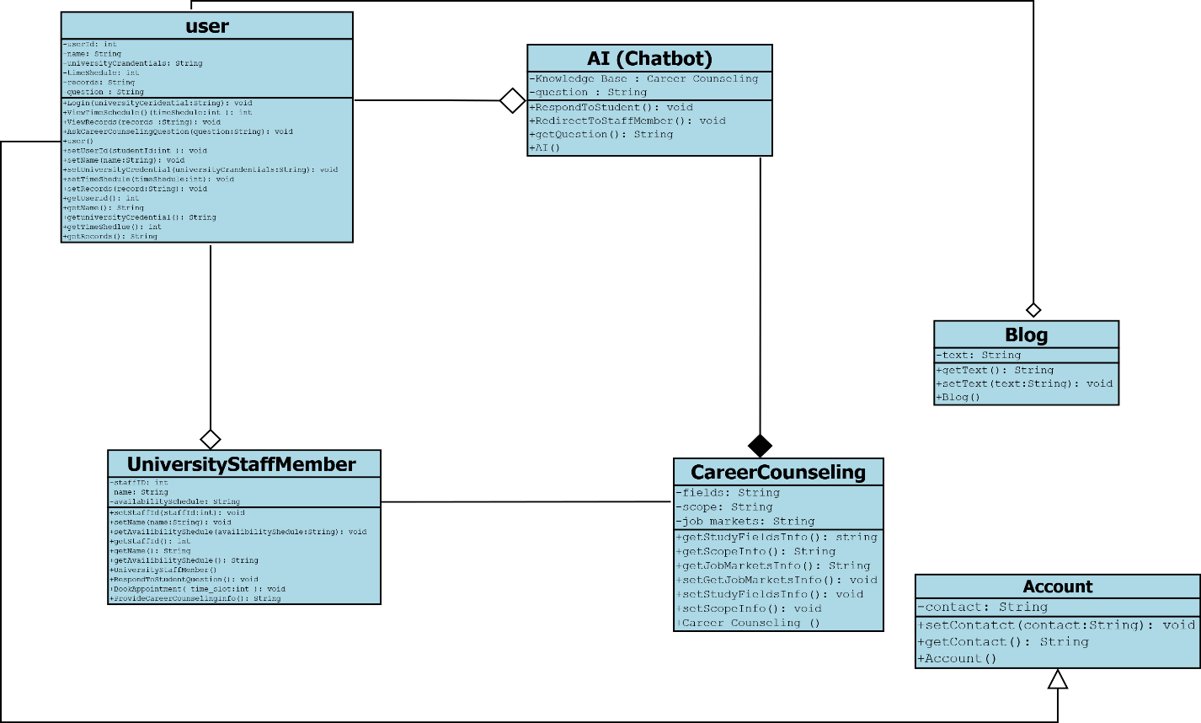

**Sequence Diagram**

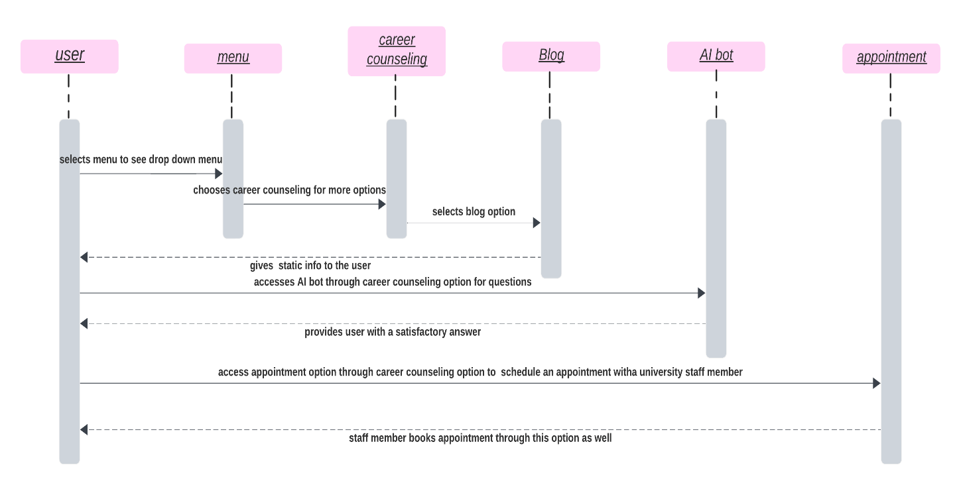

**Entity Relationship Diagram (ERD)**

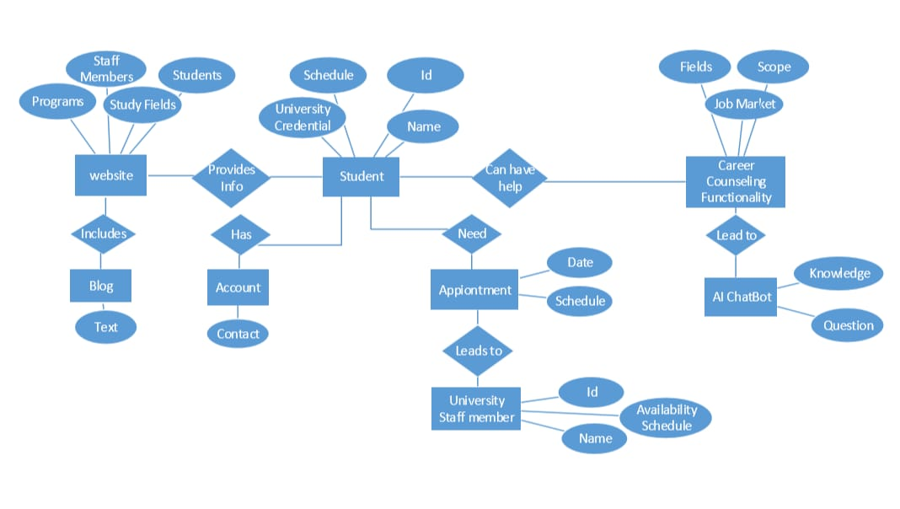

**Use Case**

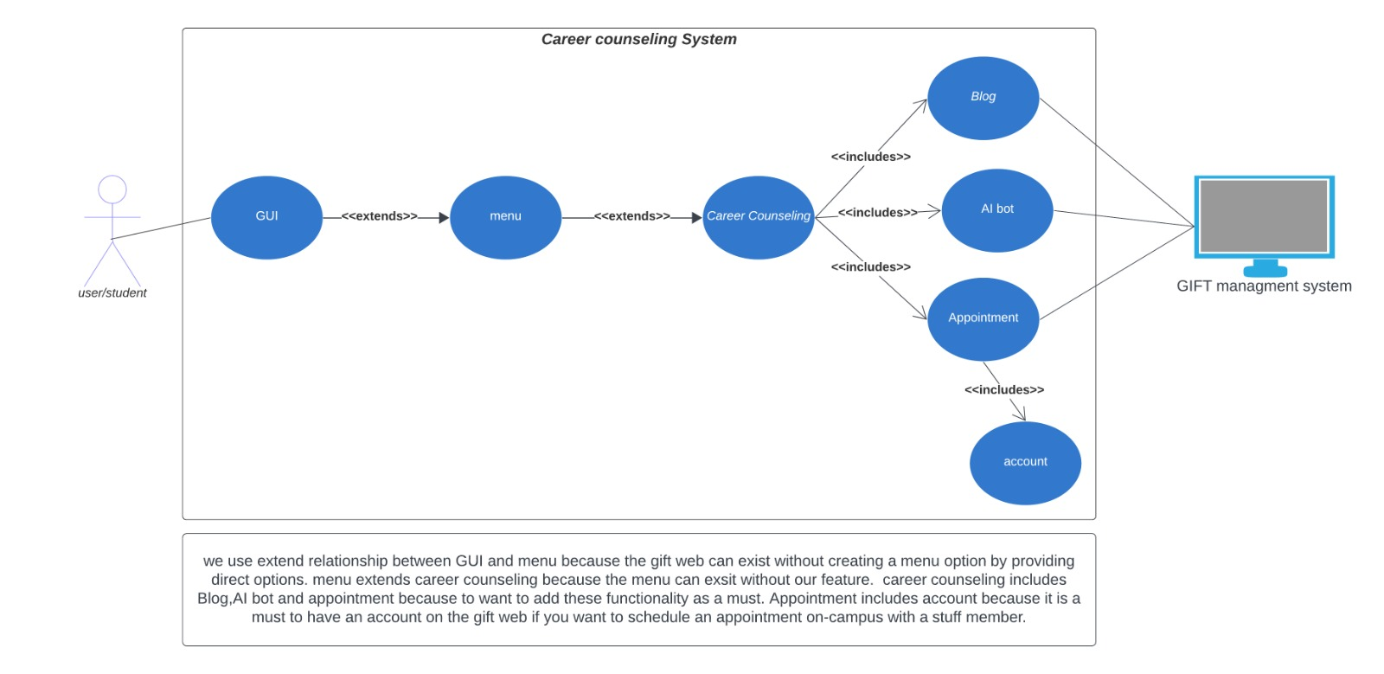

**Prototype # 1:**

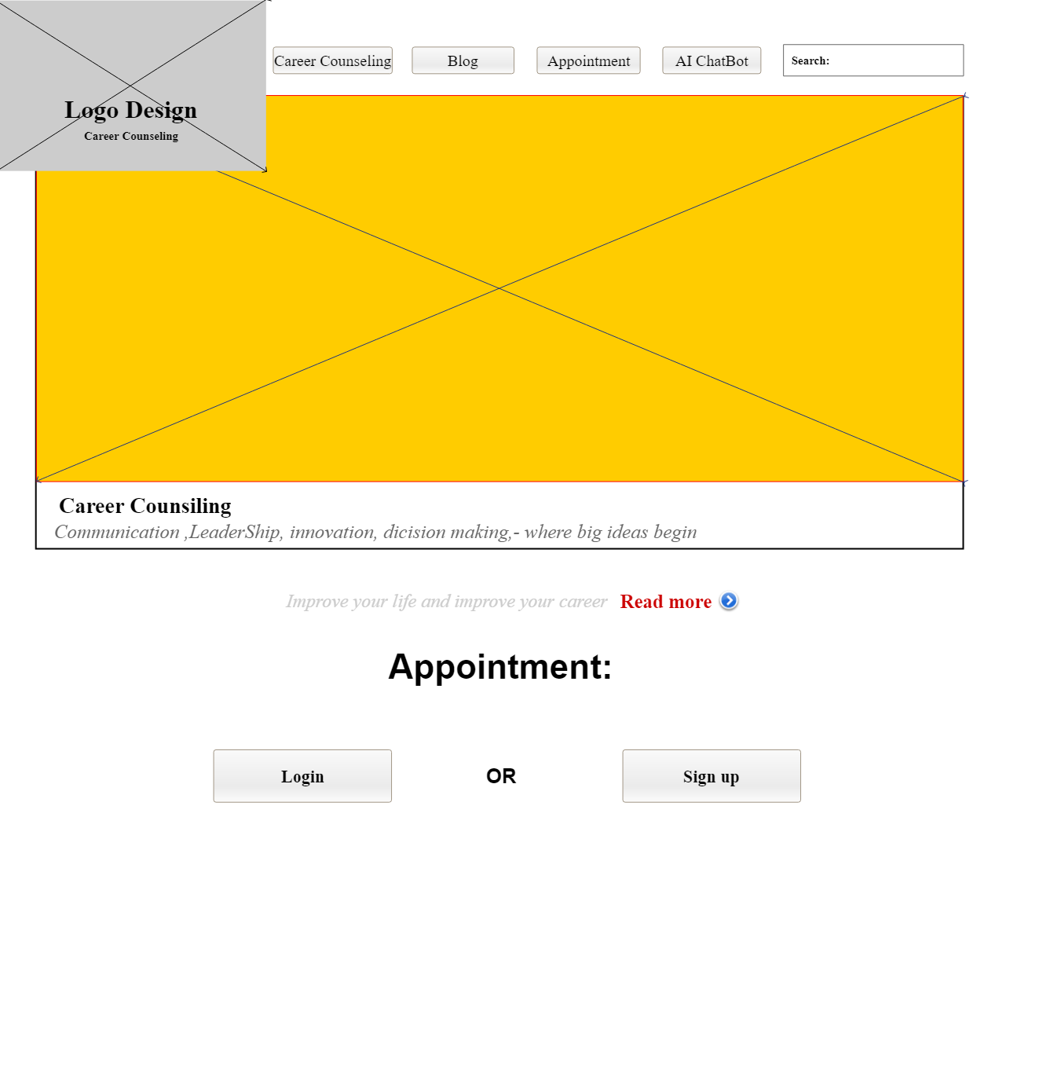

**Prototype # 2:**

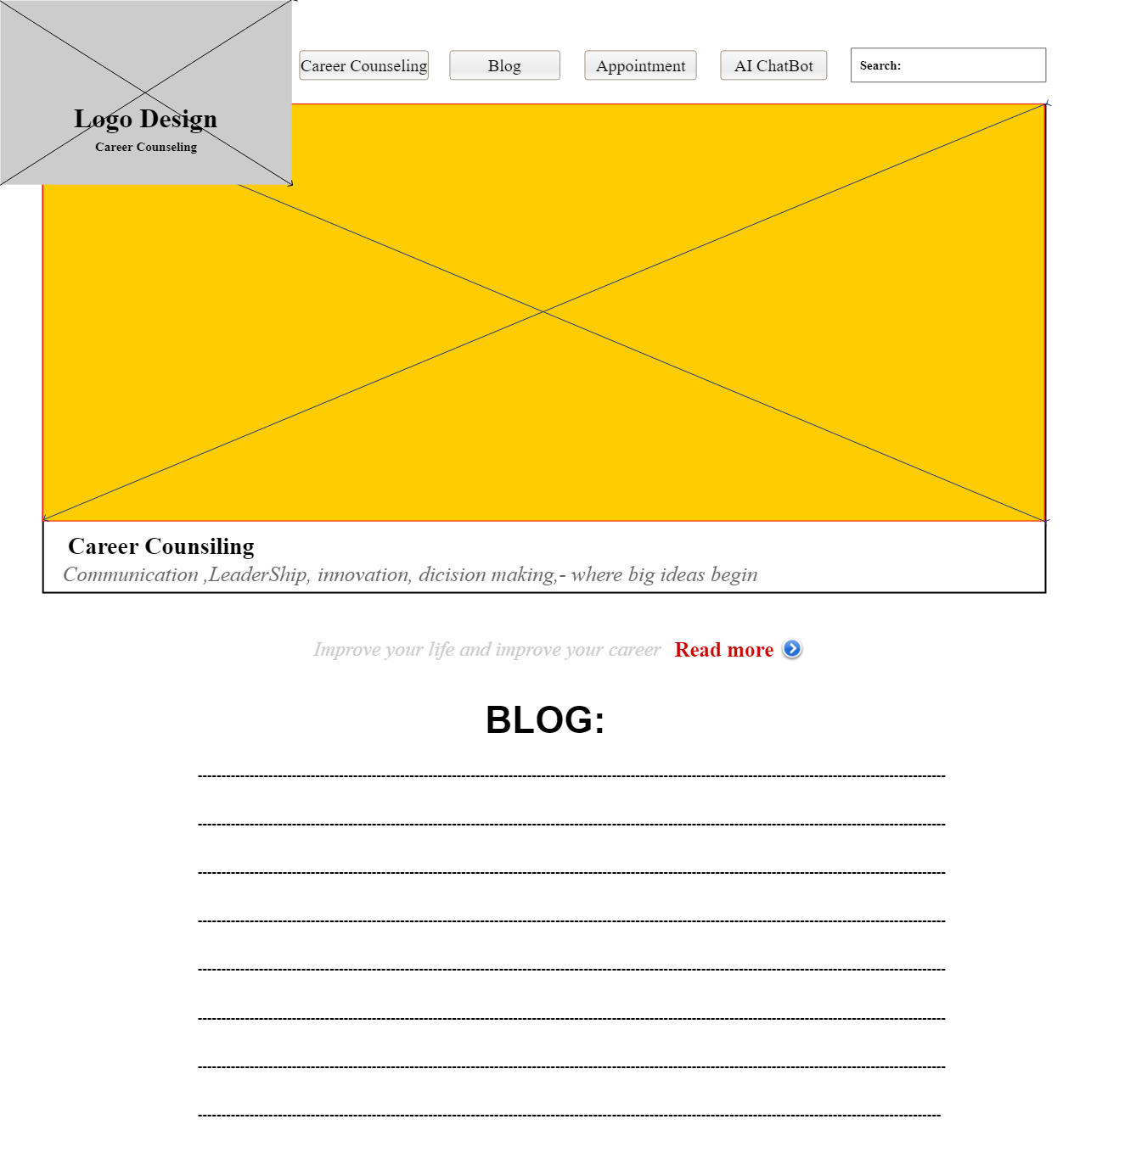

**Prototype # 3:**

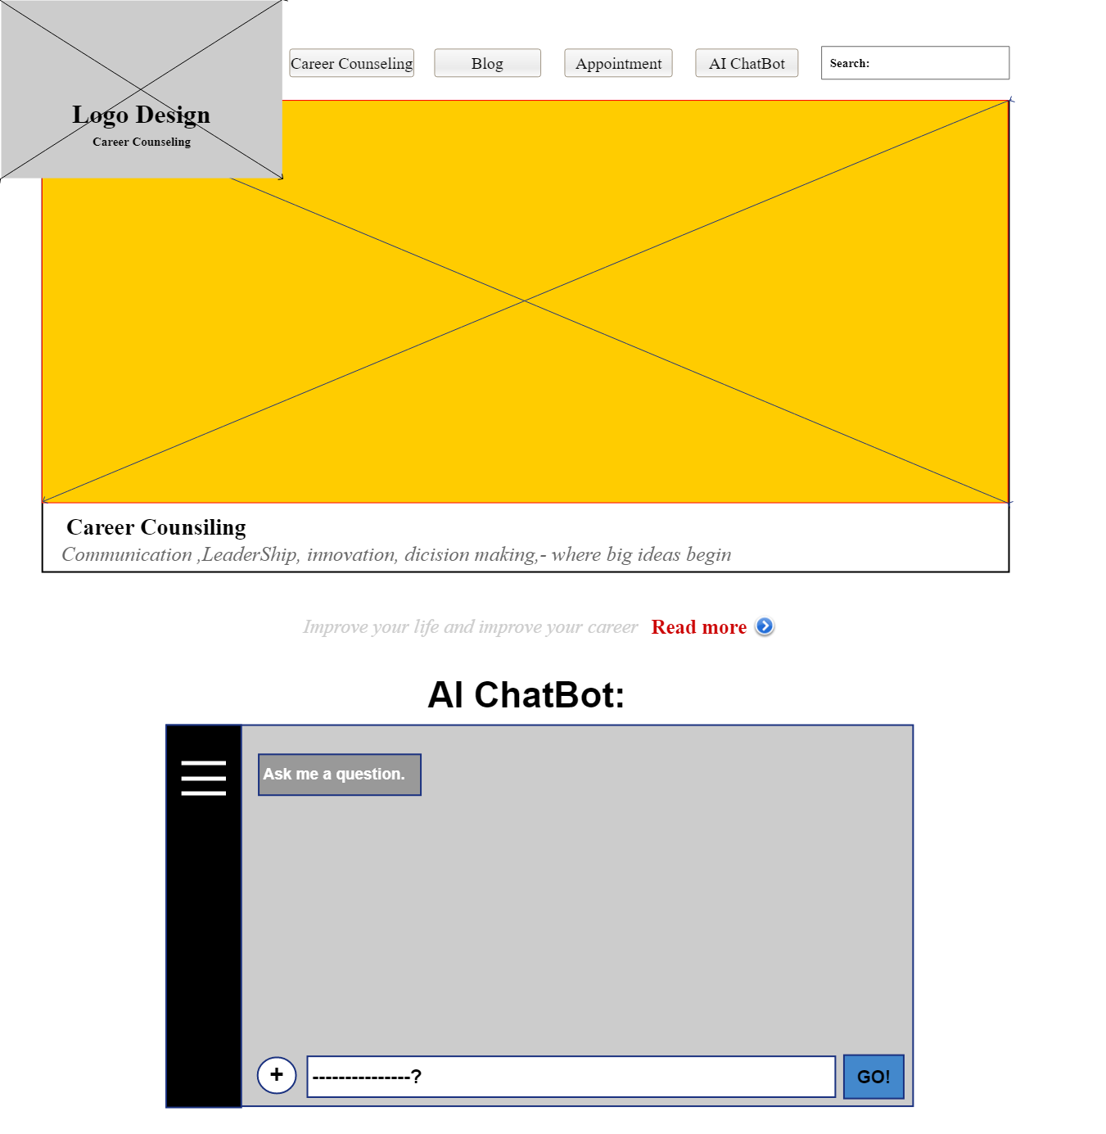

* **Ahmad Shahzad(221400077)**
* **Zerlish Burhan(221400111)**
* **Momna Asghar(221400110)**
* **Hassan Arif(221400086)**

**THANK YOU**